EXPT NO:3 | Regression and Optimization  (Multi Linear and Polynomial regression)
DATE: 06.02.2026

PRE-LAB QUESTIONS (PROVIDE BRIEF ANSWERS TO THE FOLLOWING QUESTIONS)
SCENARIO 1 – MULTILINEAR REGRESSION
Problem Statement
Predict student academic performance based on academic, behavioral, and lifestyle factors.
Dataset (Kaggle – Public)
https://www.kaggle.com/datasets/spscientist/students-performance-in-exams
Target Variable
- Final Exam Score (Average of Math, Reading, Writing)
Input Features
- Study hours per day
- Attendance percentage
- Parental education level (encoded)
- Test preparation course (encoded)
- Sleep hours

IN-LAB TASKS (Multilinear Regression)
- Import required Python libraries.
- Load the student performance dataset.
- Perform data preprocessing and encoding of categorical features.
- Select multiple input features and compute the target variable.
- Handle missing values using suitable imputation.
- Apply feature scaling.
- Split the dataset into training and testing sets.
- Train a Multilinear Regression model.
- Predict student performance for test data.
- Evaluate performance using:
- MSE
- RMSE
- R² Score
- Analyze regression coefficients to interpret feature influence.
- Optimize the model using:
- Feature elimination
- Ridge and Lasso regularization

Visualization
- Predicted vs Actual exam scores
- Coefficient magnitude comparison
- Residual distribution plot
SCENARIO 2 – POLYNOMIAL REGRESSION
Problem Statement
Predict vehicle fuel efficiency based on engine characteristics where the relationship is non-linear.
Dataset (Kaggle – Public)
https://www.kaggle.com/datasets/uciml/autompg-dataset
Target Variable
- Miles Per Gallon (MPG)
Input Feature
- Engine Horsepower

IN-LAB TASKS (Polynomial Regression)
- Import required Python libraries.
- Load and clean the Auto MPG dataset.
- Select horsepower as the independent variable.
- Handle missing values.
- Generate polynomial features for degrees 2, 3, and 4.
- Apply feature scaling.
- Split the dataset into training and testing sets.
- Train Polynomial Regression models with different degrees.
- Predict fuel efficiency values.
- Evaluate each model using:
  - MSE
  - RMSE
  - R² Score
- Compare model performance across polynomial degrees.
- Apply Ridge regression to control overfitting.

Visualization
- Polynomial curve fitting for different degrees
- Training vs Testing error comparison
- Overfitting and underfitting demonstration

SUBMISSION REQUIREMENTS
- Python code (with student roll numbers)
- Screenshot of code
- Screenshot of outputs and graphs
- GitHub repository link

OUTPUT FOR SCENARIO 1:

CODE:
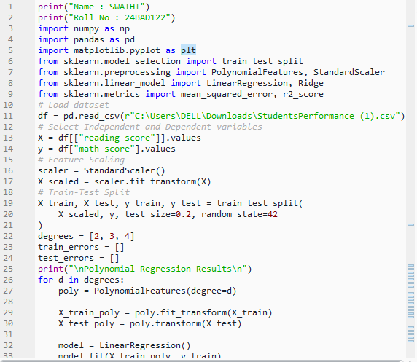
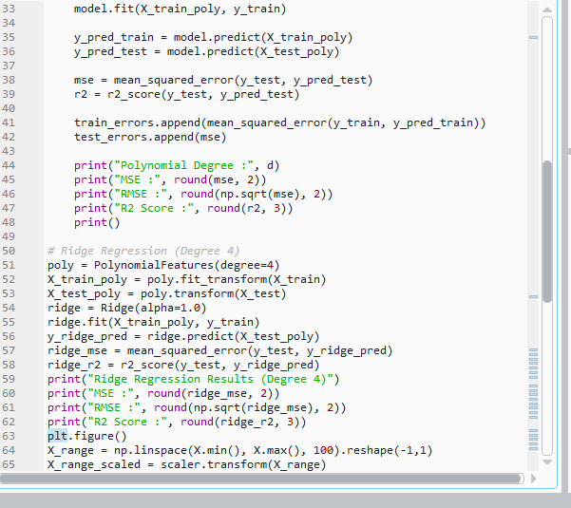
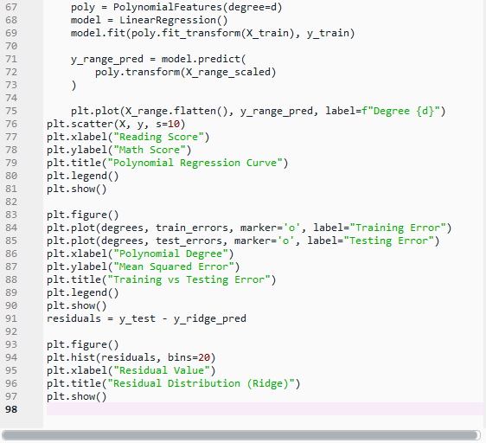

OUTPUT GRAPH
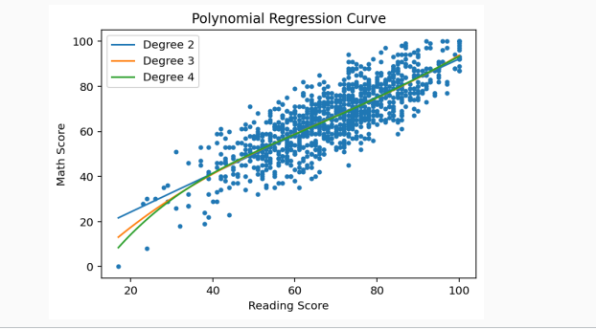

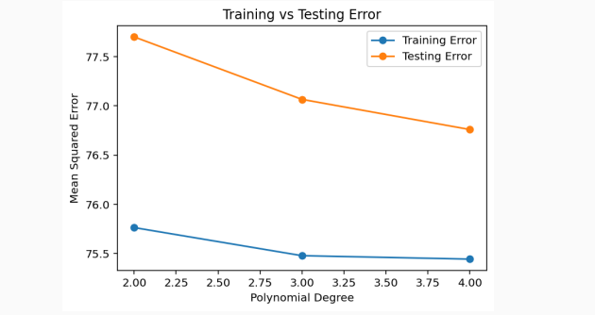
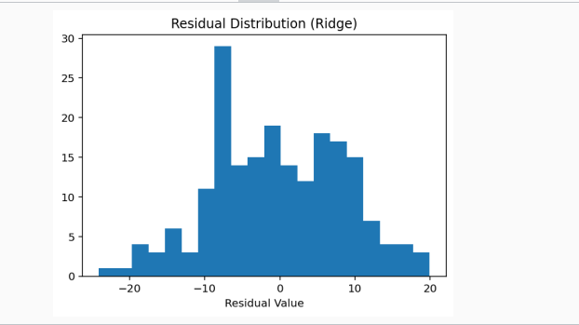

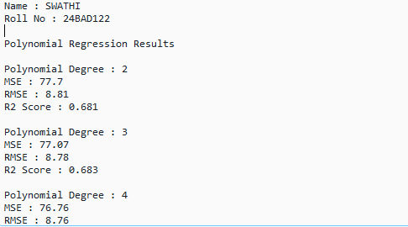
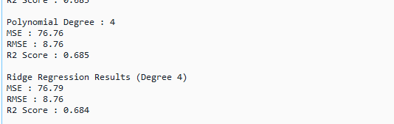

Scenario 2 – Polynomial Regression
CODE:
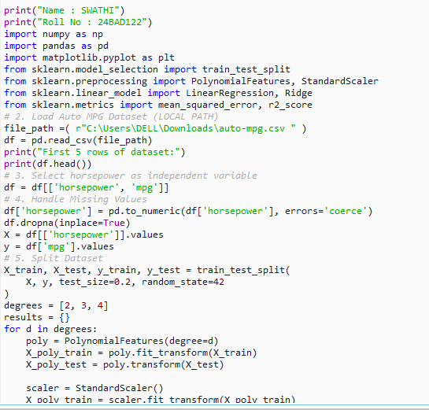
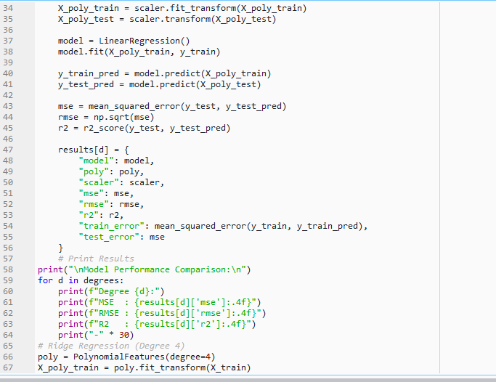
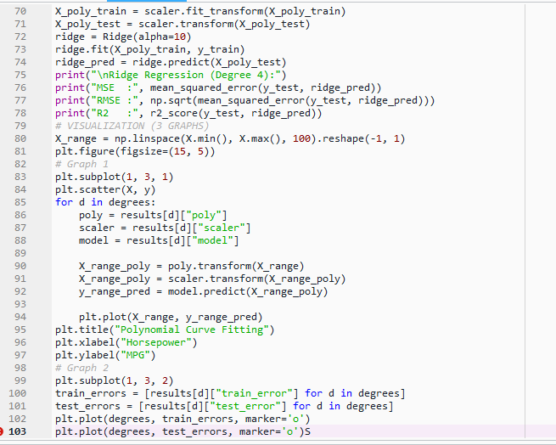
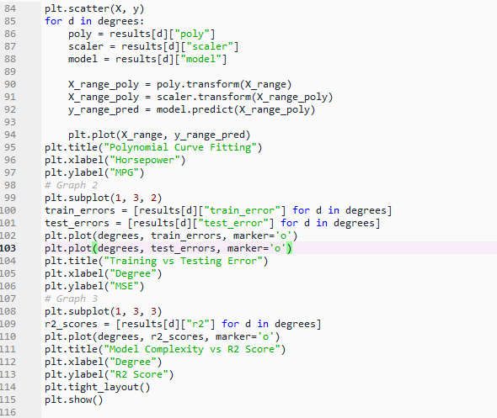

OUTPUT:
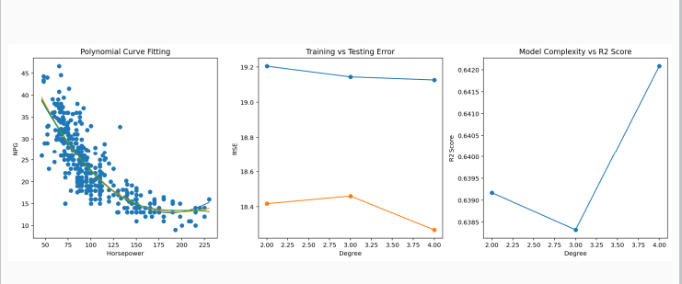

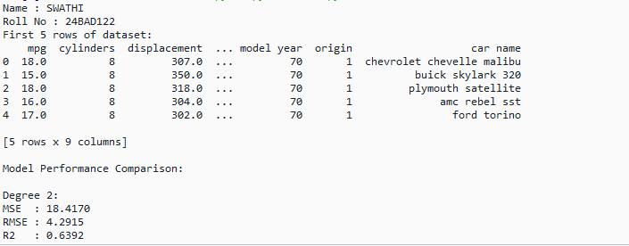
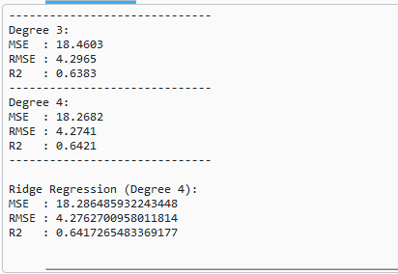
POST-LAB QUESTIONS (PROVIDE BRIEF ANSWERS TO THE FOLLOWING QUESTIONS)

